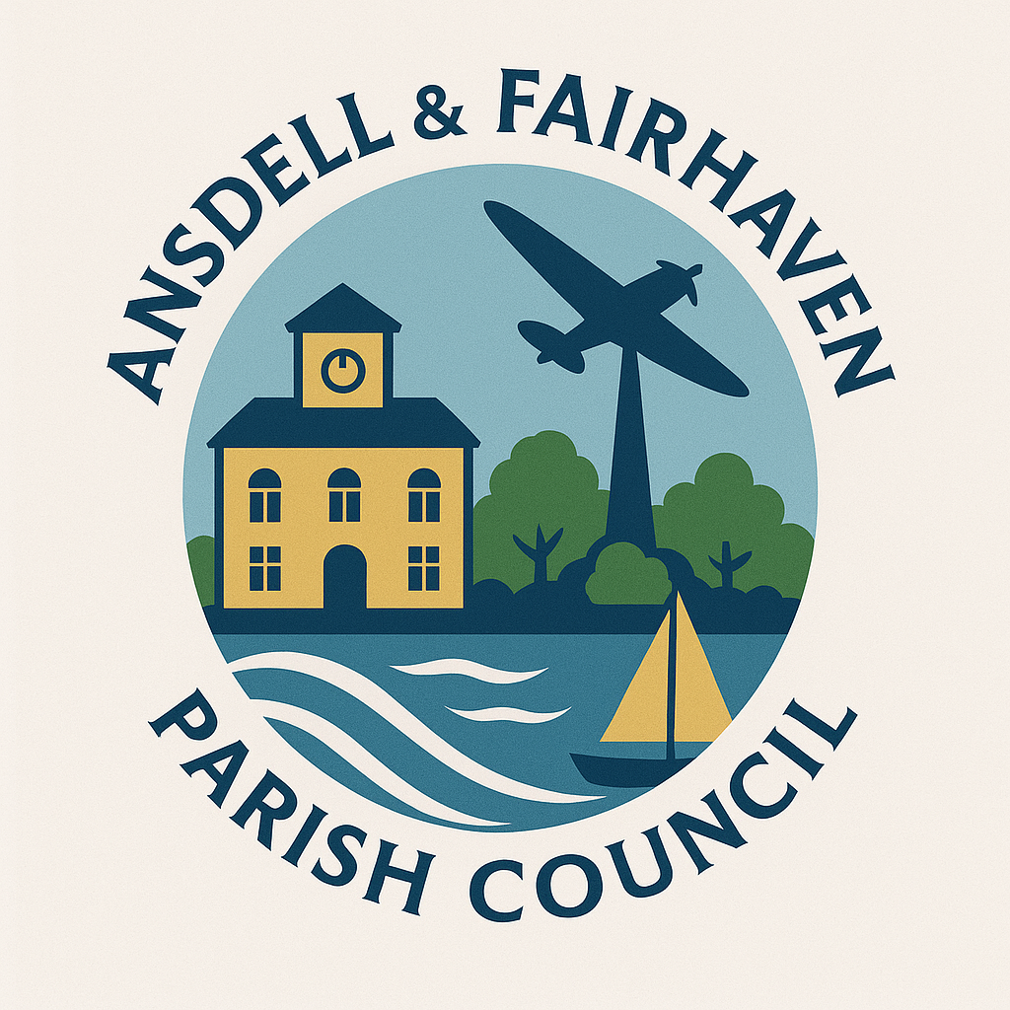
Ansdell & Fairhaven Parish Council
Minutes of the Community Engagement & Events Committee of Ansdell Parish Council held on Monday 30th June 2025 at 6.30pm at the
Ansdell Institute, Lytham St Annes.

Present: Cllr D Wilkinson, Cllr E Taylor, Cllr A Barnes, Cllr P Spilsbury.
Interim Clerk – Gill Flynn.

CE1/25 Apologies for absence.
None.

CE2/25 Declarations of interest and dispensation considerations.
None.

CE3/25 To consider the following event proposals for approval at full council:
Ansdell & Fairhaven Community Day
17th August 2025 10-4pm at the Watersports building with games, art & crafts and refreshments.
Stalls will be charged £10 and all funds raised will be donated to Ansdell in Bloom and Friends of Fairhaven Lake.
Gazebo and hi- vis jacket purchase - a budget of £1000.00 to be proposed.
Food Glorious Food
6th -12th October 2025 involving all restaurants, cafes, takeaways and outlets.
Social media campaign and posters to go in shop windows. A budget of £100 to be proposed.
Ansdell & Fairhaven Ball (to raise money for the Christmas light switch on).
8th November 2025 at the Rugby Club.
Tickets £75 with 10-12 tables of 10 available.
Host and DJ to be booked. £400 deposit needed for the venue. Prices for tablecloths and resources to be quoted.
Christmas light switch on event
29th November 2025.
Local celebrity switch on and entertainment. Local schools & church groups to be invited.

Clerk to get a quote for insurance, complete risk assessments, check on legalities of fundraising and get costs for installation of lights and Christmas tree.

CE4/25 Date and time of next meetings.
To be arranged.

The meeting closed at 7.35pm. Signed …………………………………… Date……………………………………….

